**Track It**

**A Mini-Project Report**

**Under**

**Implementation Of Technology**

***Submitted by***

**Pranay Punamiya(E015)**

**Kshitij Sabarwal(E017)**

**Anuj Shah(E022)**

***Under The Guidance Of***

**Prof Poonam Gupta**

***in partial fulfillment for the award of the degree***

***of***

**B. Tech**

**in**

**Computer engineering**

**at**



**Mukesh Patel School of Management & Engineering**

**April 2016**

**CERTIFICATE**

This is to certify that the project entitled **Track It**is the bonafide work carried out by **Anuj Shah, Kshitij Sabarwal, Pranay Punamiya** of B.Tech (Computer Engineering), MPSTME (NMIMS), Mumbai, during the fourth semester of the academic year 2015-2016, in fulfillment of the requirements for the award of the Degree of Bachelors of Technology as per the norms prescribed by NMIMS. The project work has been assessed and found to be satisfactory.

___________________

Prof. Poonam Gupta

Internal Mentor

_______________________ ________________________

Examiner 1 Examiner 2

________________________

Dean

Dr. Sharad Y. Mhaiskar

**DECLARATION**

We, **Pranay Punamiya, Kshitij Sabarwal and Anuj Shah** B.Tech (Computer Engineering), semester- IV, understand that plagiarism is defined as anyone or combination of the following:

1. Un-credited verbatim copying of individual sentences, paragraphs or illustration (such as graphs, diagrams, etc.) from any source, published or unpublished, including the internet.

2. Un-credited improper paraphrasing of pages paragraphs (changing a few words phrases, or rearranging the original sentence order)

3. Credited verbatim copying of a major portion of a paper (or thesis chapter) without clear delineation of who did wrote what.

4. We have made sure that all the ideas, expressions, graphs, diagrams, etc., that are not a result of our work, are properly credited. Long phrases or sentences that had to be used verbatim from published literature have been clearly identified using quotation marks.

5. We affirm that no portion of my work can be considered as plagiarism and we take full responsibility if such a complaint occurs. We understand fully well that the guide of the seminar/ seminar report may not be in a position to check for the possibility of such incidences of plagiarism in this body of work.

Signature of the Students:

___________ ____________ _____________

Name**: Pranay Punamiya, Kshitij Sabarwal and Anuj Shah**

Roll No.E015, E017, E022

Place: Mumbai

Date:

**Acknowledgements**

We would like to acknowledge our IOT mentor, Prof. Poonam Gupta for guiding us at every step of our project. We would also like to thank the Dean of Mukesh Patel School of Technology, Management and Management, Dr Sharad Mhaiskar for giving us this wonderful opportunity to make this app by ourselves and promote the culture of self learning.

**Table of contents**

**CHAPTER NO. TITLE PAGE NO.** Abbreviations 6

Abstract 7

List of Tables 12

List of Figures 14-19

1. INTRODUCTION

1.1 Project Overview 8

1.2 Why use this app? 8

1.3 Characteristics 8

1.4 Implementation 8

1.5 Hardware Specification 9

1.6 Software Specification 9

2. REVIEW OF LITERATURE 10

3. ANALYSIS & DESIGN 11

4. METHODS IMPLEMENTED 12

5. RESULTS & DISCUSSION 14

6. CONCLUSION & FUTURE SCOPE 18

7. REFRENCES 19

APPENDIX

**Abbreviations:**

|  |  |  |
| --- | --- | --- |
| **Abbreviations** | **Full Form** | **Description** |
| SDK | Software Development Kit | A **software development kit** is typically a set of software development tools that allows the creation of applications for a certain software package, software framework, hardware platform, computer system, video game console, operating system, or similar development platform. |
| SQLite | Structured Query Language Lite | **SQLite** is a [relational database management system](https://en.wikipedia.org/wiki/Relational_database_management_system) contained in a [C](https://en.wikipedia.org/wiki/C_(programming_language)) programming [library](https://en.wikipedia.org/wiki/Library_(computer_science)). In contrast to many other database management systems, SQLite is not a [client–server](https://en.wikipedia.org/wiki/Client%E2%80%93server) database engine. Rather, it is embedded into the end program. |

**ABSTRACT**

**Our app is Track It.** Our app is made for Android phones and tablets.

Why Android over any other platform? As quite evident, Android is the most widely used platform and is available to almost all mobile manufactures. Thus, considering its benefits and ease of use in mind, Android platform is the most suitable to consider.

Our idea is to make a user-friendly Android application that helps students keep a track of things like attendance, assignment submissions, etc.

There are two main parts to the application:

1. The attendance tracker
2. And a daily objective tracker for the user.

The attendance tracker works by using the timetable of the user and sending him notifications on which he can select whether he has attended that particular lecture.

The objective tracker allows the user to add new objectives and also view the due date and also view completed objectives.

**Salient Features of the app**

**User Friendly:** This application shall be user friendly because all the user needs to do is set a minimum attendance percentage and their time table. Once this is done they will get regular attendance updates.

**Reports are easily generated:** Using this application reports like number of assignments completed or remaining with their deadlines can be easily generated whenever and wherever the user wants.

**Alerts:** The application will give regular alerts regarding everything so that the user is well aware of his/her situation.

1. **INTRODUCTION**

**1.1 Project Overview**

In Today’s world we have many upcoming applications on every platform like iOS, Android, Windows, and Blackberry etc. Our app is made for Android phones and tablets.

Why Android over any other platform? As quite evident, Android is the most widely used platform and is available to almost all mobile manufactures. Thus, considering its benefits and ease of use in mind, Android platform is the most suitable to consider.

Our idea is to make a user-friendly Android application that helps students keep a track of things like attendance, assignment submissions, etc.

There are two main parts to the application:

1. The attendance tracker
2. And a daily objective tracker for the user.

**1.2 Why use this app?**

Many of us have faced the situation when we want to bunk a lecture but are worried about our attendance being very low or when we think we have enough attendance and bunk some more lectures but end up in the defaulters list.

This problem can be solved with this application as it will clearly tell the user how many more lectures he/she needs to attend to be clear of the defaulters.

It will give a prior notification to the user as soon as his attendance goes below the minimum attendance required in the form of an alert.

The application will also keep a record of all the assignments and their deadlines for the user thus making it easier for the user.

The user can also set small daily goals like completing 15 questions of an assignment and if he/she fails to complete it on that day then the user will be notified and the remaining pages will be shifted to the next day or any other day of user’s choice.

This app will eliminate any chance of mistake while calculating the attendance by the user.

**1.3Characteristics**

**User Friendly:** This application shall be user friendly because all the user needs to do is set a minimum attendance percentage and their time table. Once this is done they will get regular attendance updates.

**Reports are easily generated:** Using this application reports like number of assignments completed or remaining with their deadlines can be easily generated whenever and wherever the user wants.

**Alerts:** The application will give regular alerts regarding everything so that the user is well aware of his/her situation.

**1.4 Implementation**

For implementation of this idea the following things are very necessary:

1. **Database:** We need to set up a small database to store the timetable and all the assignments. This is the most important part as without this the application is useless. We are using SQLite to setup the database.
2. **Timetable and Attendance Entry:** We need to come up with an efficient and easy way to store these things.
3. **The UI:** The user interface should be smooth, fast and easy to use so that anyone can use it and it doesn’t take much of their time.

**1.5 Hardware Specification**

* Optimized for 5.5” touchscreen
* RAM requisite: 512 MB

**1.6 Software Specification**

* Android Jellybeans.
* Application size: ~5 MB
* The Android Studio software SDK v19 and build Tool v19.2.0.

**2. REVIEW OF LITERATURE**

We have selected this app for development because we wanted to come up with something that solved the everyday problems of students in our college.This app dwells upon the issue that college students are facing a lot of problems regarding low attendance.

And in today’s world where everyone is very busy, we lose track of our daily goals and objectives. Thus we aim to help everyone with our app where the can keep a track of their daily goals.

We hope to increase the productivity of our app further,byadding many different features like grouping students of same college and class, etc.

The app works by asking the user to enter and store his timetable .The user creates his timetable by adding subjects. These are stored in a database and these are retrieved as and when required.

The objective manager works in a similar fashion. The user creates a new task and also enters the deadline of the task. Then the objective is added to the database and the user can view and update the status of the database. He can also view if there are any pending tasks and also see the tasks which he has completed.

1. **ANALYSIS & DESIGN**

Perhaps the most important part of this application is the database. The app uses SQLite database built into android. Various details such as the Timetable of the user ,attendance, planned objectives of the user, etc are stored in the database. Since the SQLite database is a very lightweight one this app is also fast and smooth to use.

The user needs to enter his/her timetable only once and then the app does the job of tracking his attendance. Once the user enters his timetable he/she will get automatic notifications asking whether he/she has attended the particular lecture. On responding to the notification the database will be updated and the user can view his attendance. The app does much more than just show the user's attendance . The user can also view on what days did he miss a lecture and how many hours did he miss.

The database is discussed in detail in the next topic but for a brief idea the user enters his timetable. Four tables will be created initially.

1. The first table holds the names of the subject and each subject is assigned a unique integer value as primary key to simplify references to the subject.

2. The second table holds the users timetable which contains the timings and the duration of a lecture. They also include the day of the lecture. Each slot is assigned a unique slot id to simplify references to that slot in the future.

3. The third table is the user attendance table. This is the table which will be updated most frequently. It will refer the timetable table to keep track of which subjects have been attended and which not. It will have a status column indicating whether the lecture has been attended or not

4.This is the user objective table. It will consist of the created objectives of the user along with date of addition and date of completion. This table too will have a status column indicating a complete or incomplete objective.

1. **METHODS IMPLEMENTED**
   1. **Database creation:**

Database is the most important component of the project. And we are using SQLite for creating the database. **SQLite** is a [relational database management system](https://en.wikipedia.org/wiki/Relational_database_management_system) contained in a [C](https://en.wikipedia.org/wiki/C_(programming_language)) programming [library](https://en.wikipedia.org/wiki/Library_(computer_science)). In contrast to many other database management systems, SQLite is not a [client–server](https://en.wikipedia.org/wiki/Client%E2%80%93server) database engine. Rather, it is embedded into the end program.

We are making 3 different tables for the database. These three tables are:

1. **Subject List:**

This table will contain the lecture name and its id. Its main purpose will be just to maintain a list of all the lectures that the user has.

|  |  |
| --- | --- |
| Sub_id | Sub_name |
| Maths | S_1 |
| Operating system | S_2 |

The table above shows table ‘Subject List’ with some dummy values.

1. **Template:**

This table will store the main time table of the user. It will have all the details like the timings of all the lecture, the duration of the lecture, the day, etc.

Once this table is made there will be no further changes made while calculating the attendance thus this is the basic framework.

|  |  |  |  |  |  |
| --- | --- | --- | --- | --- | --- |
| Slot_id | Day | Start_time | End_time | No_hrs | Sub_id |
| 1 | Monday | 11 | 12 | 1 | S_1 |
| 2 | Monday | 12 | 14 | 2 | S_2 |

This table has ‘Sub_id’ as the foreign key from the table ‘Subject List’.

1. **Attendance:**

This is the table where the attendance of the user is stored and all the calculations for the user’s attendance will be done from this table. It stores the number of hours the user has missed, etc.

|  |  |  |  |
| --- | --- | --- | --- |
| Att_id | Slot_id | Date | Status |
| 4 | 3 | 20/3/16 | 1 |
| 5 | 4 | 20/3/16 | 0 |

The status here indicates if the user attended the lecture or no, if it has 1 then it means lecture attended and 0 means otherwise.

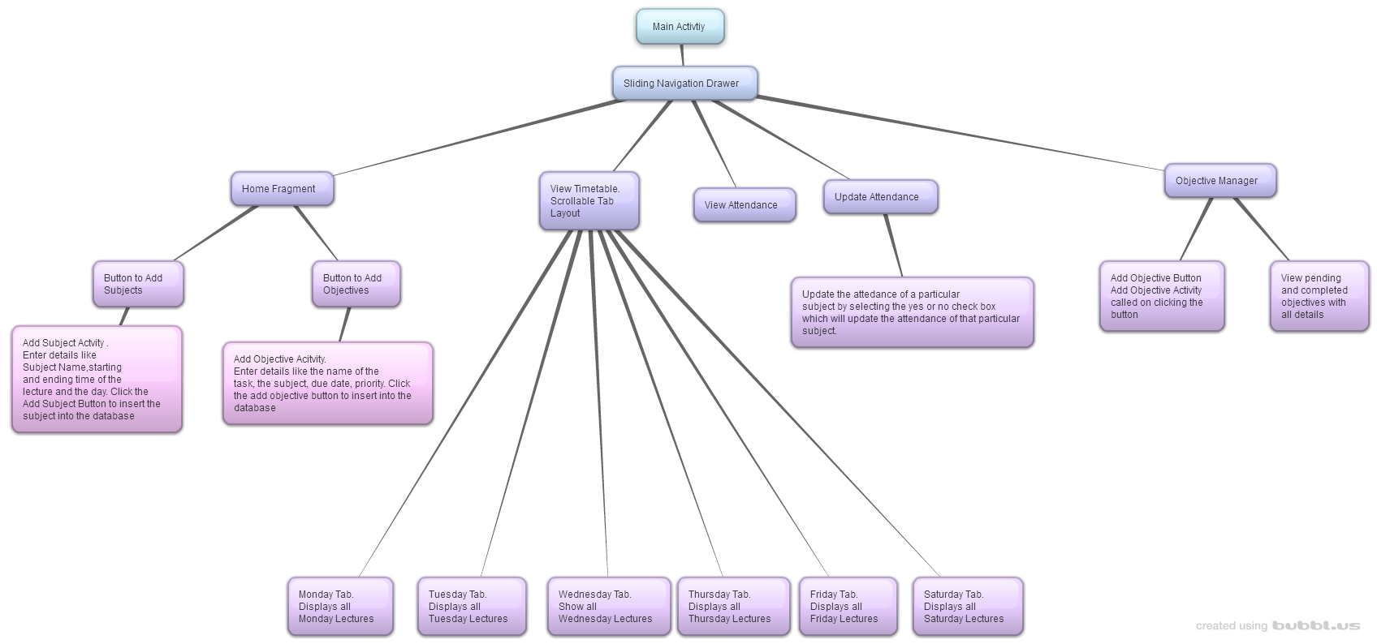

**Flowchart**

This is the general flow of the app. To navigate between activities and fragments a sliding navigation drawer is used.

1. **RESULTS & DISCUSSION**

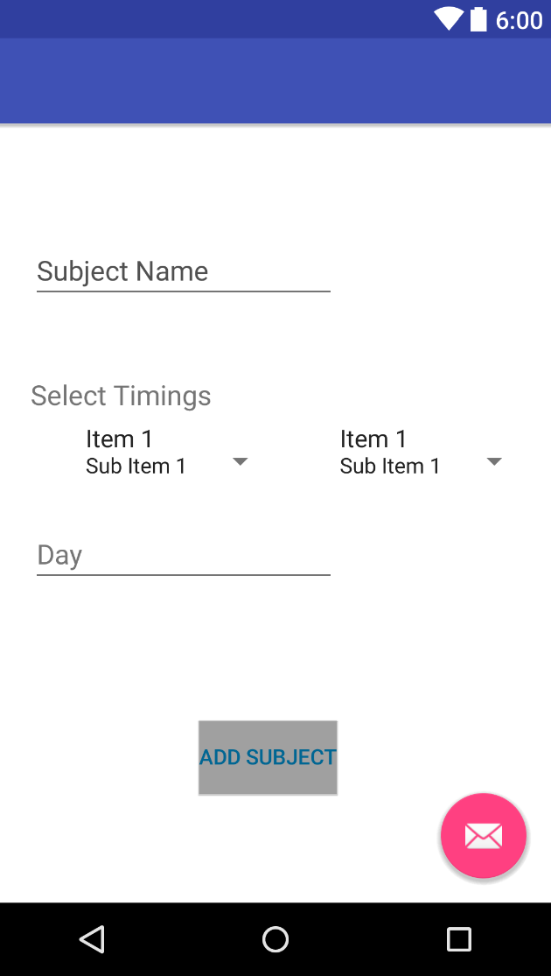

This the page where the user enters his timetable in the database. He has to input the subject name and their timings and the day it’s on. Once this is done there is no need to enter the timetable ever again.

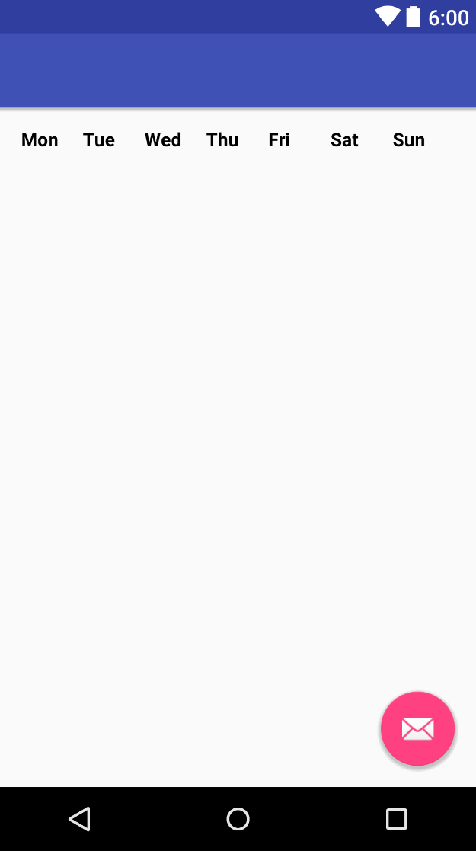

This is the page where the user can look his timetable up it will have all the subjects with their timings and we plan on showing the user whether he has attended a particular lecture or not on this page itself.

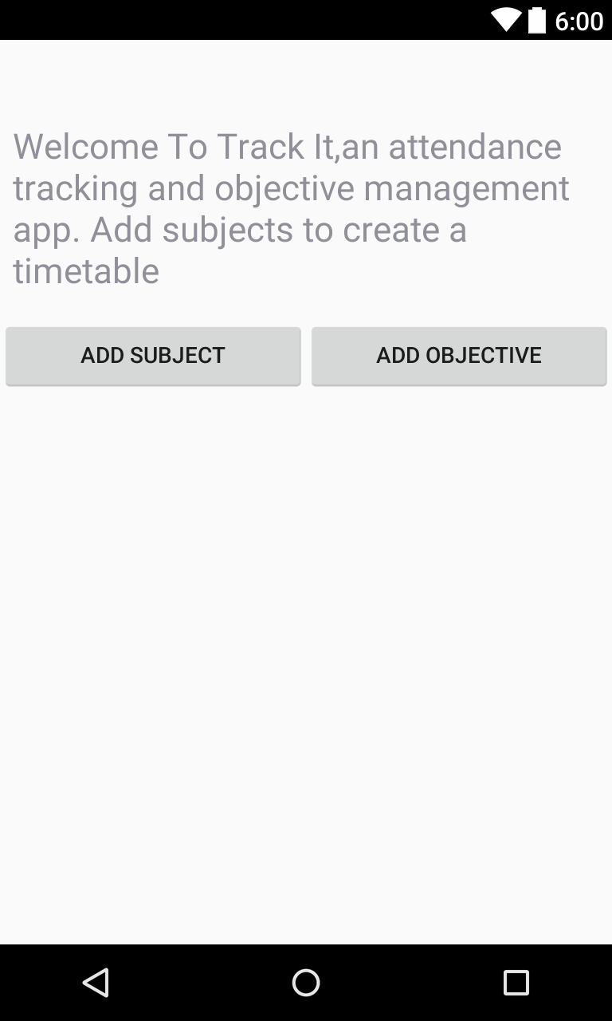

Using this activity the user can choose to add either a subject to update his timetable or create a new objective .

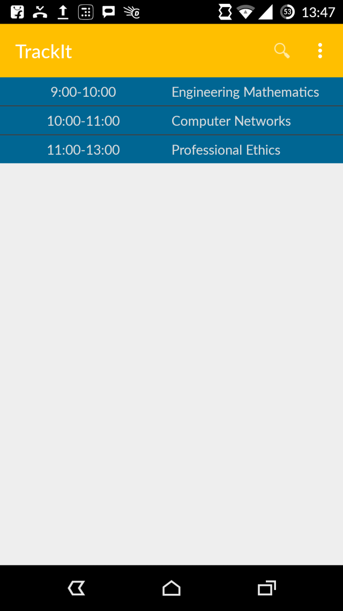

This fragment shows us the timetable in day view format. The timetable shows us the subjects of a day in a ListView format .

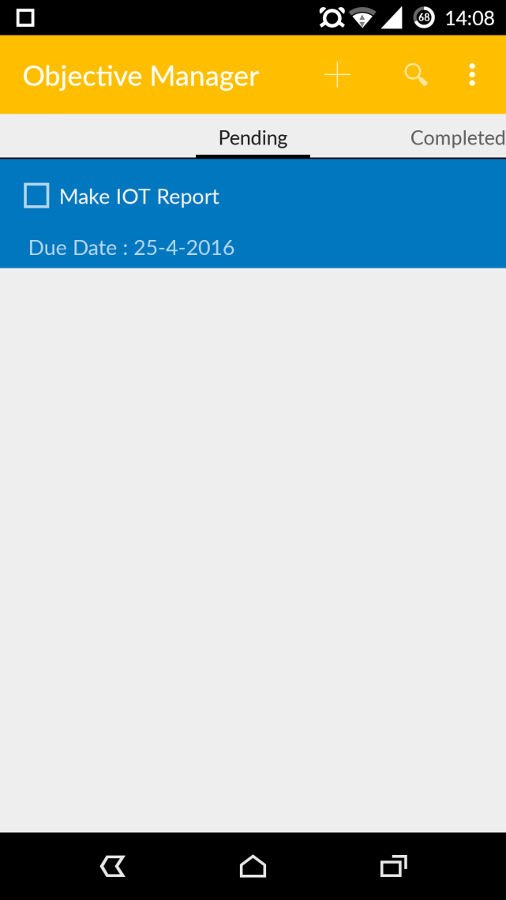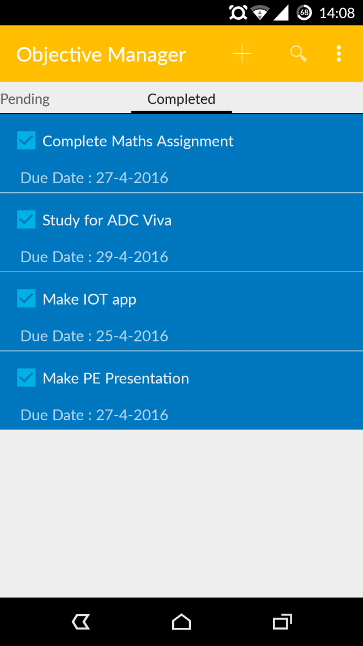

This is the Objective Manager Page. Here the users can view their created objectives. The layout of the page is such that the user can swipe between tabs to view completed and pending objectives.

1. **FUTURE SCOPE**

Forming groups: This will allow students in the same class to make and join one group. This way only one person has to input the timetable

Adding user specific database to allow them to upload respective faculty information or college related information

Notes sharing which allows one user to upload notes to be accessed by anyone in his group.

**7. REFERENCES**

<https://thenewboston.com/videos.php>

<https://www.youtube.com/>

https://developer.android.com

https://androidhive.info

http://stackoverflow.com